MSP AIRPORT BADGE IDENTIFICATION

REQUIREMENTS FOR U.S. CITIZENS

January 2019

New and renewing badge holders applying for a MSP security badge must present Two (2) original documents that establish identity and employment eligibility. One must be a photo. Expired or photocopied documents will not be accepted. We do NOT accept municipal ID cards.
If you are a U.S. Citizen born in the United States:
Present one ID that shows identity and one ID that shows employment eligibility (from either List A or List B).

Examples of acceptable combinations:
- Passport and Driver’s License or State ID
- Passport and Social Security Card
- Driver’s License and Social Security Card
- Driver’s License and Certified Birth Certificate

If you are a U.S. Citizen born outside the U.S.:
In addition to providing one photo ID that shows identity, you must also establish citizenship and employment eligibility by showing one of the following:
- U.S. Passport
- Certificate of Birth Abroad:
-Form DS-1350
-Form FS-545
-Form FS-240
- Certificate of Naturalization and Social Security card. (Certificate of Naturalization is not an approved form of identification; therefore, the Social Security card must accompany the Certificate of Naturalization.)

Examples of acceptable combinations:
- Passport and Driver’s License or State ID
- Certificate of Naturalization and Social Security Card and Driver’s License or State ID

List A | List B
Documents that Establish  IDENTITY | Documents that Establish  EMPLOYMENT ELIGIBILITY
- U.S. Passport Card or Passport  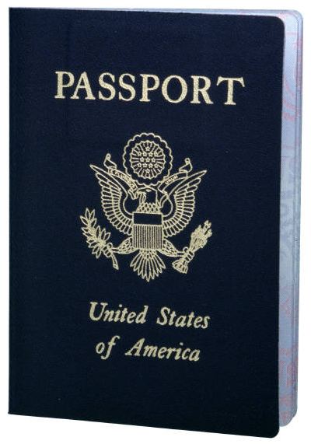  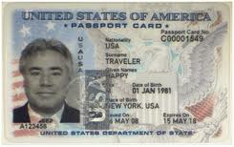  - State-issued driver’s license  - State-issued ID card  - Canadian driver’s license  Address on license or state ID card must be the address where you reside (unless you are a student with a current student ID)  We will accept a clipped Driver’s License accompanied by the DMV issued white receipt showing change of address, name correction, or renewal  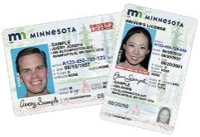  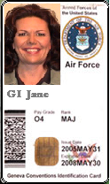  - U.S. Military card  - Government ID card issued by federal, state or local government agencies or entities provided it contains a photo and information such as name, date of birth, gender, height, and eye color, (i.e., FBI, FAA)  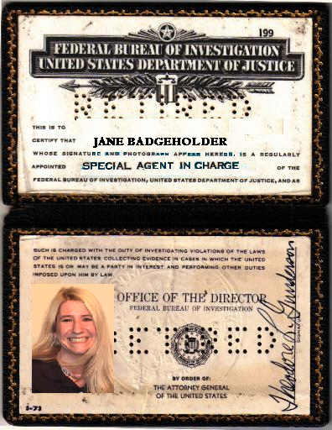 | - U.S. Social Security card  Not accepted: Metal or plastic reproductions or if the card specifies that it does not authorize employment in the U.S.  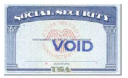  - Certified birth certificate issued by state, county, municipal authority or outlying possession of the United States bearing an official seal. A birth certificate issued by a hospital will not be accepted. Your full name must be printed on the birth certificate.  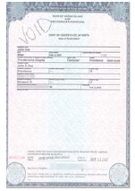  - U.S. Passport Card or Passport  - Certification of Birth Abroad issued by the Department of State  -Form DS-1350  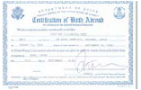  -Form FS-545  -Form FS-240  - Certification of Naturalization  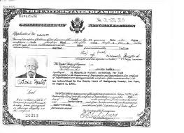

MSP AIRPORT BADGE IDENTIFICATION

REQUIREMENTS FOR NON-U.S. CITIZENS

January 2019
Documents that Establish
IDENTITY and EMPLOYEE ELIGIBILITY
- Permanent Resident Card

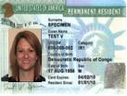

- Foreign passport with I-551 temporary stamp
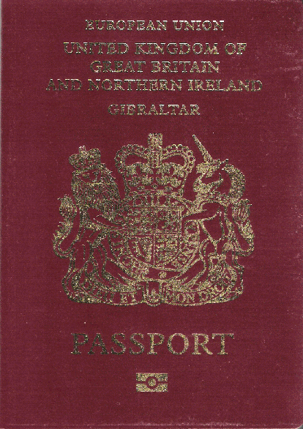
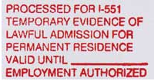

- Foreign passport with machine-readable immigrant visa with I-551

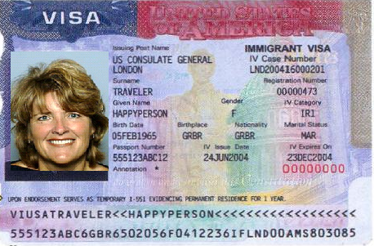

- Employment Authorization document issued containing a photograph

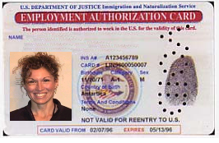

- Nonimmigrant Exchange Visitors Visa (J-1 or F-1 Status) must be accompanied by proper documentation. Student exchange visitors also need a letter from their responsible school officer.

If you are NOT a U.S. Citizen – You must present an original, unexpired INS document along with a second document from List A or List B on reverse side of this handout.

Examples of acceptable combinations:
- Permanent Resident Card and Driver’s License or State ID
- Permanent Resident Card and Social Security Card
- Employment Authorization Card and Driver’s License or State ID
- Employment Authorization Card and Social Security Card

